OS LAB ASSIGNMENT 1

SINADIN SHIBIN , R4 , 64
06-05-2021

EXCERCISE 1

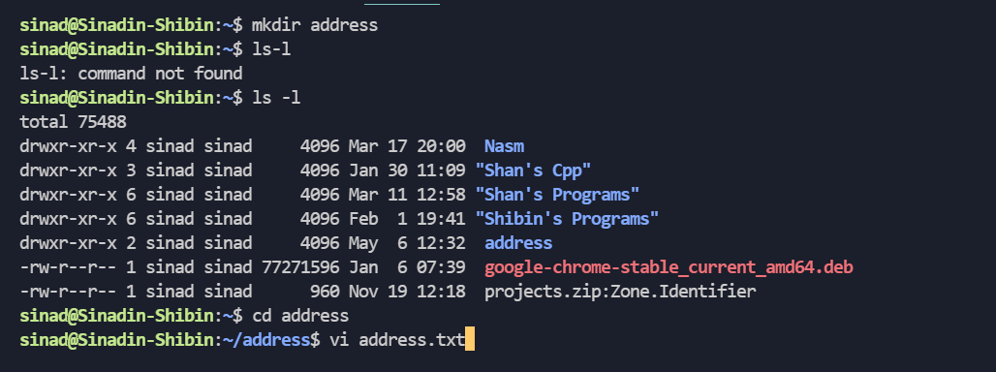

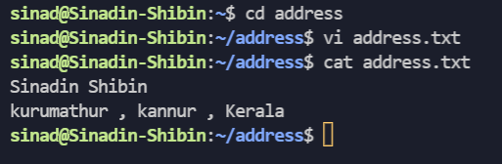

EXCERCISE 2

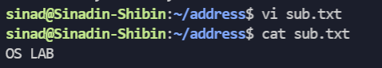

EXCERCISE 3

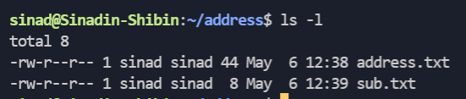

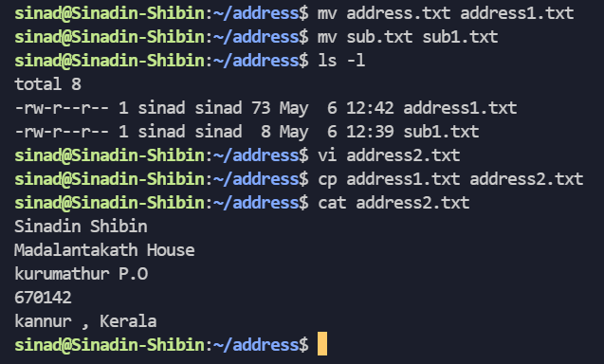
EXCERCISE 4 , 5

